Case Study: Online Retail

I. Executive Summary

This case study analyzes over one million online retail transactions to identify customers, products, and markets that contribute most to revenue, while also examining customer churn, seasonal demand, and potentially fraudulent or erroneous transactions. Using customer-level feature engineering, RFM analysis, predictive modeling, time-series methods, and transaction classification techniques, the study evaluates how transactional data can be converted into actionable business insight. The analysis confirms that revenue is primarily generated through a relatively small group of customers and markets, with a “Champion” segment of customers accounting for the majority of customer-attributable revenue, and the United Kingdom dominating overall sales performance. At the product level, several items demonstrated consistently strong demand, while others showed statistically significant declines in sales over time. Revenue trends also revealed clear seasonal fluctuation in product demand and purchasing behavior, with major spikes in November and December corresponding to holiday purchasing surges.
The study demonstrates how predictive analytics and exploratory data analysis can support more effective business decision-making in marketing, retention, and risk management. Customer churn models showed that balancing the training data substantially improved sensitivity, making models more useful for identifying customers at risk of churning. A promotional response model performed exceptionally well in separating customers into actionable response tiers, providing a practical foundation for targeted campaigns with the aim of increasing return on marketing investment. Additionally, an anomaly detection framework and random forest classification model successfully distinguished standard sales from returns, administrative adjustments, and suspicious negative transactions, offering a structured basis for fraud screening and audit prioritization. Overall, the findings suggest that a combination of descriptive analytics, customer segmentation, forecasting, and machine learning can help the online retailer improve profitability, allocate resources more strategically, and reduce operational risk.
The fraud and anomaly detection model achieves near-perfect AUC scores across six of its eight classes, with Bulk.Inventory.Adjustment, Debt.Financial.Adjustment, and Small.Promo.Gift all reaching 1.00, indicating the model separates these classes from the rest with complete confidence — the weakest AUC of 0.85 belonging to Standard.Sale and 0.85 to Missing.Customer.ID reflecting the inherent difficulty of distinguishing those classes from base features alone. The promotional response model is similarly strong, with all three tiers achieving AUC scores above 0.999, indicating near-perfect separation between High, Medium, and Low response customers across the board. The advantages and shortcomings of both of these models will be further elaborated upon in later sections.

II. The Problem
An online retailer seeks to improve its sales performance by developing a deeper understanding of its customers and purchasing behavior. A stronger understanding of customer activity would allow the company to implement targeted marketing campaigns, which can improve profitability by increasing marketing return on investment. In addition, identifying high-value customers may allow the retailer to develop retention strategies that secure a stable base of recurring revenue. The company is also interested in developing methods for detecting fraudulent or abnormal transactions, which can reduce financial losses caused by chargebacks, stock depletion, and costly dispute investigations while maintaining customer trust. Finally, the retailer hopes to improve inventory and pricing decisions by identifying patterns in demand related to seasonality, product trends, and regional market differences.
The objective of this study is to analyze transactional data in order to identify key revenue drivers, detect anomalous purchasing activity, and uncover patterns in customer purchasing behavior. Specifically, this study seeks to answer the following questions:
- Which customers and international markets contribute the most to overall revenue?
- How can high-value customers be identified and targeted through marketing or retention strategies?
- What patterns or seasonal trends exist in product demand?
- Can abnormal or potentially fraudulent transactions be detected using patterns in the data?
We hypothesize that several identifiable patterns will emerge from the analysis. First, we expect to observe meaningful seasonal fluctuations in purchasing behavior. Second, we anticipate that revenue contributions will be highly concentrated among a relatively small number of countries and customers. Third, we expect that customers can be segmented based on purchasing behavior in ways that provide useful insights for targeted marketing and retention strategies. Finally, we anticipate that abnormal purchasing activity will produce identifiable patterns that can be used to flag potentially fraudulent or erroneous transactions. For this online retail dataset, the primary challenge was not just identifying what was sold, but understanding the nature of what was lost or misleading from our perceived pattern and behavior of the transactional data.
The remainder of this report is organized as follows. First, we review relevant analytical and predictive methods that can be used to address the research questions. Next, we describe the dataset and the data preprocessing steps required for the analysis. We then present the analytical approach and findings of the study. Finally, we conclude with key insights and recommendations for the retailer.

III. Review of Related Literature

Retail analytics has relied on statistical and machine learning techniques to better understand customer purchasing behavior, product demand, and transaction activity. Research has developed both theoretical frameworks and practical applications that help businesses analyze customer transactions, detect anomalies, and improve marketing and operational decisions.
One commonly used framework in marketing analytics is Recency-Frequency-Monetary (RFM) analysis, which evaluates customer value based on how recently a customer purchased, how often they purchase, and how much they spend. RFM analysis was originally developed as a marketing segmentation technique and has been widely applied in customer relationship management to identify high value customers and guide targeted marketing strategies (Fader et al., 2005). Retailers frequently use RFM-based segmentation to improve customer retention and personalize promotional campaigns. Another important area of research focuses on identifying product demand trends and sales patterns. Statistical methods such as regression analysis are commonly used to evaluate changes in product demand over time. Regression models allow for researchers to estimate relationships between time and product sales in order to identify products that are gaining or losing popularity (James et al., 2021).These models help businesses identify declining products, adjust inventory levels, and update product offerings. Time-series forecasting models such as the Autoregressive Integrated Moving Average (ARIMA) model are frequently used to predict future demand based on historical sales patterns. ARIMA models analyze trends, seasonality, and autocorrelation in time series data to generate forecasts for future periods (Hyndman & Athanasopoulos, 2021). These models have been widely applied in retail demand forecasting to improve inventory planning and reduce stock shortages or excess inventory.
Another widely used analytical technique in retail analytics is market basket analysis, which identifies items that are frequently purchased together in the same transaction. Market basket analysis relies on association rule mining techniques that identify relationships between products based on co-occurrence within transaction data (Tan et al., 2019). Retailers commonly apply these techniques to design product bundling strategies, cross-selling recommendations, and targeted promotions that increase the average value of customer purchases.
Finally, anomaly detection methods have become an important part of transaction analysis. Machine learning algorithms such as Random Forest models have been widely used for detecting unusual or fraudulent transactions because they capture complex, nonlinear relationships in the data while remaining robust to noisy observations (Breiman, 2001). In retail environments, these models have been used to identify abnormal purchasing behavior, transaction errors, or potentially fraudulent activity. A report conducted by Abed Mutemi and Fernando Bacao (2023) researched the efficacy of numeric-based machine learning predictive models for organized retail crime (ORC) detection in digital marketplaces. We are not focused specifically on ORC for the purposes of this case study, but rather a broader look at the transactions of an online retailer. Nevertheless, their methodologies and results prove to be a worthwhile reference for our own pursuits. One of the highest performing models in their report was a random forest sampling model on a balanced dataset. We explored a similar methodology in this report when attempting to create a model to systematically detect possible fraudulent and anomalous behavior in our dataset using a classification response variable that was derived from feature engineering on the original dataset.
Breiman, L. (2001). Random forests. Machine Learning, 45(1), 5–32. https://doi.org/10.1023/A:1010933404324
Fader, P. S., Hardie, B. G., & Lee, K. L. (2005). RFM and CLV: Using iso-value curves for customer base analysis. Journal of Marketing Research, 42(4), 415–430. https://doi.org/10.1509/jmkr.2005.42.4.415
Hyndman, R. J., & Athanasopoulos, G. (2021). Forecasting: Principles and practice (3rd ed.). OTexts. https://otexts.com/fpp3/
James, G., Witten, D., Hastie, T., & Tibshirani, R. (2021). An introduction to statistical learning: With applications in R (2nd ed.). Springer. https://doi.org/10.1007/978-1-0716-1418-1
Tan, P. N., Steinbach, M., & Kumar, V. (2019). Introduction to data mining (2nd ed.). Pearson.
Mutemi A, Bacao F. (2023). A numeric-based machine learning design for detecting organized retail fraud in digital marketplaces. https://pmc.ncbi.nlm.nih.gov/articles/PMC10397305/#Abs1

IV. Methodology

This case study will analyze transactional retail data to identify patterns in customer purchasing behavior, product demand, and transaction activity. The dataset contains over one million transactions recorded over approximately two years and includes information such as invoice number, product description, quantity purchased, unit price, customer identifier, transaction date, and customer location. Several analytical approaches were applied to address the research questions that were outlined in the problem statement.
The dataset includes both numerical and categorical variables. The primary numerical variables used in the analysis include Quantity, which represents the number of items purchased in a transaction, and Price, which represents the unit price of each product. From these variables, a Revenue variable was created as the product of Quantity and Price. Categorical variables include Description, which represents the product name, InvoiceNo, which identifies each transaction, CustomerID, which identifies individual customers, and Country, which represents the geographic location of the customer. Time-related analysis is conducted using the InvoiceDate variable. This variable is transformed into monthly time periods in order to analyze seasonal patterns, product demand trends, and time-series forecasting.
The analysis uses the full dataset of available transactions, rather than a sampled subset of the data. Because the dataset already contains the complete set of available transaction records for the period studied, no additional sampling techniques were required. The dataset consists of secondary data collected from an online retail company’s transaction records. Each observation represents a product purchase within a transaction and includes information on the product purchased, quantity purchased, product price, and transaction date.
Several analytical techniques are used in the project. Descriptive aggregation methods are used to identify the top selling products by units. Linear regression analysis is used for the monthly product sales data in order to identify products that are declining in popularity . Monthly units sold are used as the response variables and time is used as the explanatory variable. Time series forecasting is used to estimate future demands for selected high-volume products, monthly units sold are converted into time series data and modeling using an automated AIRMA forecasting model. Product pair analysis is used to identify items that are frequently purchased together within the same transaction.
On customer-level analytics, a fair amount of feature engineering was utilized to attain more relevant metrics that could be applied toward identifying who the high-value customers are, and their contributions to overall revenue. After collapsing data into a customer dataset based on customer ID, the many new features created include, but are not limited to: total revenue, first and last order dates, total unique skus, number of orders, interpurchase days median and mean, and preferred month (fig. 18). These new features lay the foundation for RFM analysis, which scores each customer on a 1-5 scale based on their recency (how long ago their last order was), frequency (of purchases), and monetary value (revenue generated).
The simplest way to determine who the highest revenue-generating individual customers are is to rank them by total revenue generated, but this approach is not robust due to the skewness of the distribution of total revenue per customer. Instead, RFM analysis is conducted by creating 5 equal-sized bins of customers on the variables recency_days (R), n_orders (F), and total_revenue (M), which were stored as individual variables and then summed to create a total RFM score variable (fig. 20).
In order to capture more information about individual customer behavior, customers were segmented into 7 distinct segments based on the scores of each component of RFM: Champion, Loyal Low Spender, Big Occasional Spender, New Customer, Low Engagement, At-risk High Value, and Regular Customers (and a “No Segment” bin where customers did not fit into any of the 7 segments; fig. 4).
A key business question in any retail context is whether promotional spend is being directed at the right customers. Rather than applying promotions broadly across the customer base, the goal here was to build a model that could predict which customers are most likely to respond to a promotion. This targeted promotional campaign would allow marketing efforts to target customers more efficiently in a pursuit to achieve higher ROIs. Customers had already been segmented into meaningful business groups using RFM scoring, and those segments were mapped into three promotional response tiers — High, Medium, and Low — based on their likelihood to engage with a promotion. Champions and Loyal Low Spenders were assigned to the High tier given their strong engagement history, At-risk High Value and New Customers to the Medium tier as uncertain but worthwhile targets, and the remaining segments to the Low tier where promotional spend is least likely to generate a return.
Customers were classified into three response tiers — High, Medium, and Low — based on their predicted promotional responsiveness, giving the business a practical ranked output it could act on directly. A Random Forest model was trained using the ranger implementation for computational efficiency, with hyperparameter tuning performed over three values of mtry using 3-fold cross-validation, optimising for Mean F1 score to account for class imbalance across the three tiers. Prior to training, a preprocessing recipe was applied to the training data that encoded the country variable using dummy variables, binned rare countries into an "other" category, normalised all numeric predictors, and applied a hybrid resampling strategy combining SMOTE oversampling of minority tiers with downsampling of the majority tier to produce a balanced training set. To prevent data leakage, the raw RFM scores, composite RFM totals, and the segment labels themselves were all excluded as predictors, since they were directly derived from the same behavioural data used to define the target variable. CustomerID and date columns were also removed as they carry no predictive signal for new entries. The remaining predictors — including recency days, number of orders, total revenue, tenure, and purchase rhythm metrics — were retained as the genuine behavioural signals the model should learn from. The variable importance results confirm that recency_days, n_orders, and total_revenue are the dominant predictors, which is expected given that the tier labels were intentionally designed around those concepts. This is a sign of internal consistency rather than a flaw — the model has learned to replicate the segmentation logic from raw inputs alone.
To determine which international markets generated the highest revenue, as well as which exhibited the fastest sales growth, countries were grouped together and their aggregate total revenues were generated for the entire time period of the dataset, as well as per month. The per-month revenues were used to calculate month-over-month revenue growth, and individual country contribution to revenue was calculated on a monthly period as well as the period of the whole dataset.
A churn variable was created to define a recency threshold at which 95% of repeat customers return for another purchase using the variable recency_days (days since last order). This global “churn threshold” was calculated only for customers who have made multiple purchases with the retailer, as churn is more aligned with retention of repeat customers than acquisition of new customers, i.e. one-time buyers. A diagnostic scatter plot showing days since last purchase in relation to number of orders confirms that one-time buyers are heavily concentrated throughout the dataset, which is common in the retail industry (fig. 5). However, customers with a low number of purchases increase in concentration as days since last purchase increases, confirming that inclusion of one-time buyers would inflate the churn threshold (red line), which would fail to capture the 95th recency percentile of customers who the business intends to retain. After filtering out one-time customers, the churn threshold was found to be about 206 days, meaning if a repeat customer does not return within 206 days, they are labeled positive for a new boolean variable, churn_flag (fig. 22).
Two predictive models were used to predict churn_flag: logistic regression and random forest. Due to the abundance of dummy variables that would need to be created for the factor variable “country”, this variable was compressed to a boolean “fromUK”, because about 91% of total customers were from the U.K. In addition, preferred_month was converted from integer to factor because the dataset spans more than one year, and month numbers are not indicative of time sequence in this dataset. Removal of many variables before fitting models was necessary because of multicollinearity issues due to the fact that many variables in the customer features dataset were calculated using other variables in the same dataset. In addition, variables that captured recency data, like recency_days and r_score, were removed to prevent against data leakage to the target, churn_flag.
Because the goal of the model is to predict churn_flag = TRUE for churned customers, a type II error is more critical than a type I error. It should be the goal, then, to minimize type II error by prioritizing sensitivity scores over specificity scores. To do this, the dataset used for churn training was balanced using all observations for which churn_flag = TRUE, and a random sample of the same number of observations for which churn_flag = FALSE (fig. 21).
Predictor importance for the logistic regression model was then calculated by centering and scaling variables to enable comparison of overall effect, measured by each predictor’s coefficient estimate. Predictor importance for the logistic regression model was then calculated by simply taking the absolute value of each coefficient estimate and ranking them alongside the importance rankings for the random forest model.
Standard reporting often lumps all non-sales into a single "return" bucket, masking operational inefficiencies and potential fraud. Potential liabilities like unaddressed anomalies—such as high-value negative quantities, missing customer identifiers, and unexplained debt adjustments—represent "Value at Risk." Without a clear classification system to filter out normal transactions from outliers, the business cannot, for example, distinguish between a legitimate and traceable customer return and a system error or internal fraud. This lack of transparency leads to skewed ROI metrics, misguided auditing efforts, and prevents the implementation of targeted risk-mitigation strategies. We aim to address these concerns with the introduction of feature engineering to filter out anomalous data, implementation of a classification system to assign consistent labels to filtered out data, and creation of a predictive model capable of detecting possible fraudulent transactional behavior for our online retailer. All this is to build a foundation to facilitate strategies to remedy these leakages. We began by engineering a logic-driven classification system. Unlike a standard "Total Sales" view, I isolated Return Candidates (negative quantities or "C" prefix invoices) and Pure Purchases. Using high-value thresholds and string-matching for administrative codes (e.g., "A" prefix for Debt), We categorized every transaction into one of eight distinct audit classes. This ensured that specific anomalies, like $0.00 price promotions or bulk inventory write-offs, were surfaced rather than buried. For the predictive phase, we chose the Random Forest algorithm on a balanced stratified dataset . This model was selected for its ability to handle non-linear relationships and its inherent resistance to outliers. Because the data was severely imbalanced (i.e. Standard Sales vastly outnumbering Debt Adjustments and other classifications), we utilized SMOTE (Synthetic Minority Over-sampling Technique) and downsampling. This "Hybrid" approach synthetically generated rare anomaly cases to ensure the model could recognize them, while the inclusion of class weights forced the model to prioritize the correct identification of high-risk categories over simple majority accuracy.
Several limitations should be noted. The dataset spans only approximately two years of transaction activity, which limits the length of historical data available for time-series forecasting. As a result, prediction intervals for future demand may be relatively wide. In addition, some products appear only for short periods of time, which may represent discontinued or seasonal products rather than long-term demand trends.

V. Data

The dataset provided to us came in the form of a .xlsx file with two sheets, which contained a multitude of issues that needed to be addressed before any meaningful analysis could take place. The data contained 8 variables and roughly 1.07 million observations, with each observation representing a product – represented through a stock code and description – on a particular invoice number. After importing the two sheets and combining them into a single dataframe, it was found that there were several thousand null values in “Description” and several hundred thousand in “Customer ID.” Addressing descriptions first, since there is another variable, stock code, that should have a one-to-one relationship with description, we tried imputing descriptions if the null description occurred on a row with a stock code value that exists on a different row that does contain a description value. This imputation reduced the number of missing descriptions from almost 4,400 to 363 (fig. 19). For the rest of the missing descriptions, the value was filled in with text that simply referenced the stock code, e.g. “Unknown (StockCode 84032B)”. For the missing customer IDs, a similar strategy was implemented: if the row with missing customer ID shared an invoice ID with a row where customer ID was not null, the null would be replaced by the not null customer ID. Unfortunately, the results of this imputation were less successful than in the description column, and there were no other data to use to impute customer IDs. Considering removing the rows with null customer IDs, we thought it necessary to take into consideration the potential effects of omitting such a large portion of the data (22.8% of total observations), and it was determined that these rows/invoices with null customer IDs comprised 13.7% of total revenue spanning 12 countries. This represents a non-negligible portion of the data, so after completing the final cleaning step of removing about 34,000 duplicate rows, two datasets were created: one dataset, df_all, contained all observations, including ones with nulls in customer ID. This dataset was meant to be used for seasonal trends, product tracking, and anomalous purchases. The other dataset, df_cust, contained only those observations in which customer ID was not null, and was meant to be used for customer-level analytics.
One other notable issue with the data was that, although each observation was meant to capture one product type on a particular invoice, it was found that some invoices contained multiple listings of the same product, but in different quantities. For example, in invoice # 489560, the product “REX CASH+CARRY JUMBO SHOPPER” is listed twice with quantities 1 and 3.
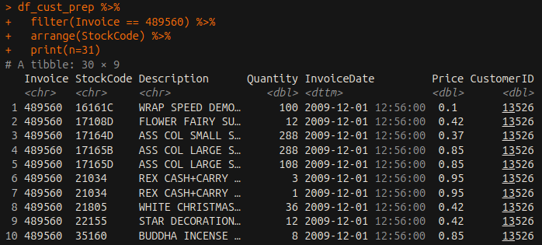
Because our analyses always take into consideration the combination of product and quantity to determine unit volume and revenue metrics, this inconsistency in the data is of little consequence for our analyses, so long as we can assume that the true quantity of products purchased is equal to the sum of both columns. So, for the example above, the true quantity of “REX CASH+CARRY JUMBO SHOPPER” purchased is assumed to be 3 + 1.
Throughout the course of our analyses, it was discovered that customers were heavily concentrated in the U.K. (about 91% of customers), and training predictive models using the leveled predictor country often required models to prepare n-1 dummy variables for 43 unique country levels. Due to the already limited number of features in the data, the creation of this many additional predictors was concerning due to the likelihood that it would dilute true influence of other predictors when measuring prediction of things like customer churn. Because of this, a boolean variable was created called “fromUK”, which only indicated whether or not a customer was from the U.K.
Additionally, there were several preprocessing steps to ensure that the dataset accurately reflected purchasing behavior. Revenue was calculated as the product quantity and unit price, and transaction dates were converted into monthly time periods in order to analyze seasonal purchasing patterns and perform time series forecasting. For the product trend analysis products were required to have a sufficient amount of sales history and recent activity in order to ensure that the short lived or discounted products were not incorrectly classified as declining items. Further, some products appear only briefly within the dataset which may represent season or promotional items rather than long term inventory products. These factors may introduce variability in the trend and forecasting analyses.
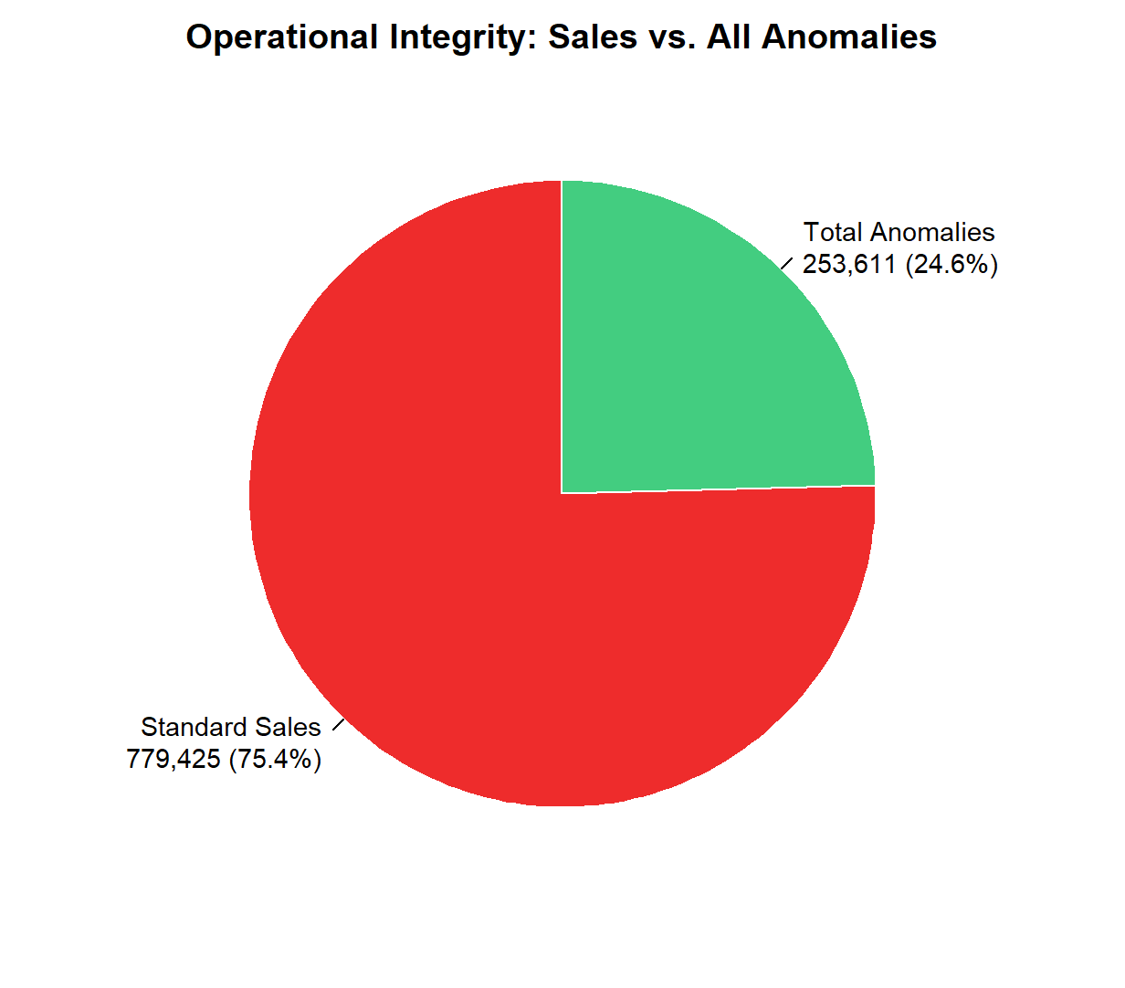
As a foundation for the fraud detection model, a total sale value column was calculated by multiplying quantity by price, which also naturally captures negative values arising from returns and cancellations — an important signal for anomaly detection. Several feature engineering steps were performed to enrich the dataset and flag suspicious or non-standard transactions. Stock codes were examined for description inconsistencies, where a single code mapping to multiple descriptions was flagged as a potential data integrity issue. Transactions were then categorised into distinct types based on a combination of invoice prefix patterns, price values, and quantity signs. Return candidates were identified as any transaction with a negative quantity or a "C"-prefixed invoice, while debt adjustments were flagged using "A"-prefixed invoices or negative prices. Zero-price transactions were further split into small promotional gifts and bulk inventory adjustments based on quantity thresholds. A high-value flag was also applied to any transaction whose absolute total value exceeded the 99th percentile of the distribution, capturing both unusually large sales and large reversals.

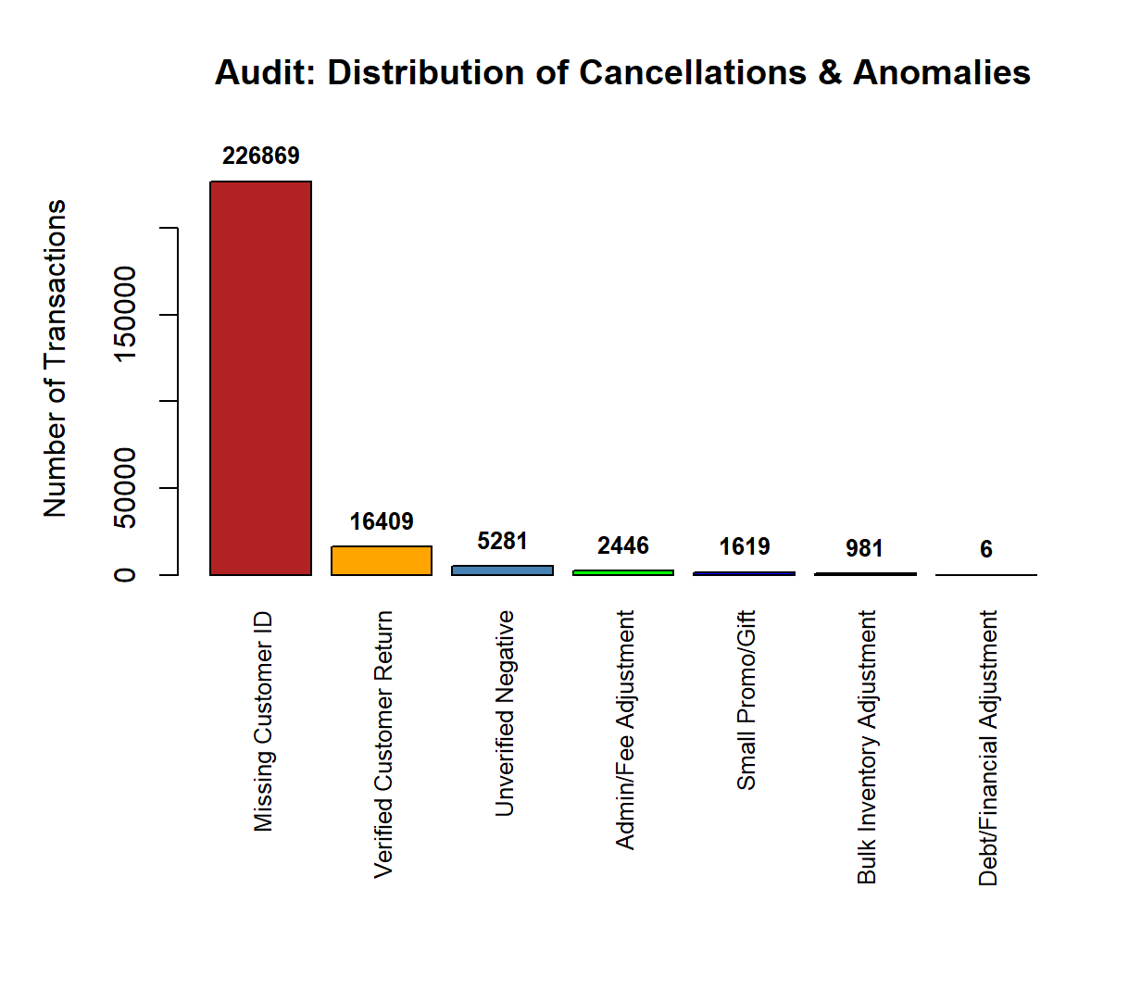
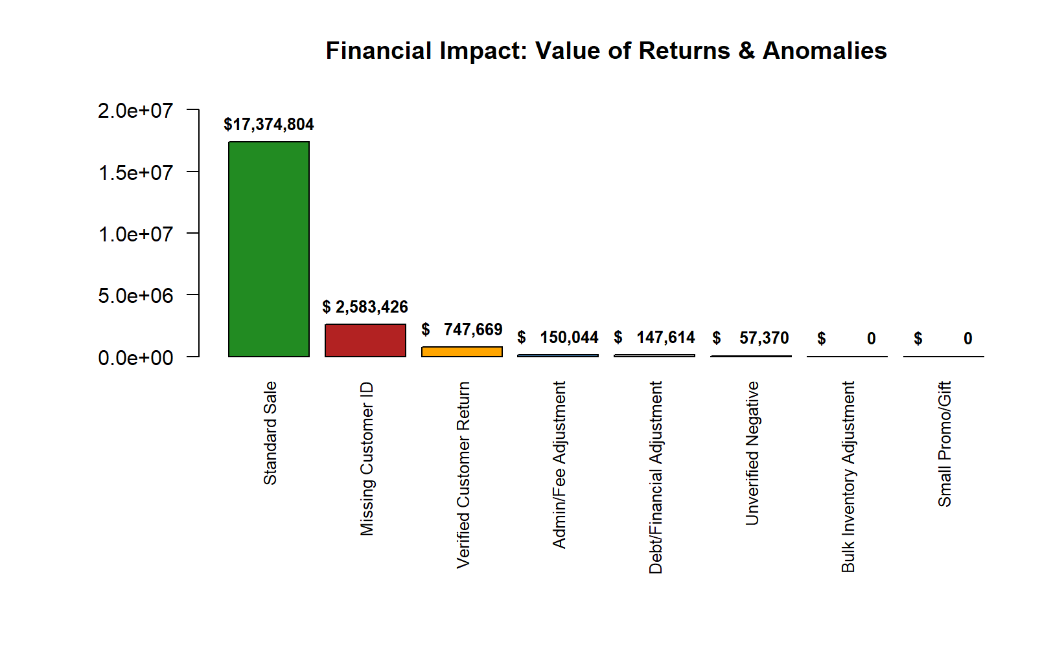
To build a reliable audit trail, verified returns were matched back to their original purchase using customer ID, stock code, price, and country, with an additional check ensuring the return occurred after the original purchase date and did not exceed the original quantity. Any return candidate that could not be matched to a prior purchase was labelled as an unverified negative — a key anomalous signal, worth marking for further investigation into potential fraudulent activity. These engineered flags were then combined into a master classification column assigning each transaction one of eight labels, which served as the target variable for the random forest model.

As part of the exploratory analysis, return rates were examined at both the country and product level to identify where reversals are most concentrated. To ensure the results were meaningful and representative, a minimum transaction threshold was applied to filter out countries and products with very low overall activity — entries with too few transactions were excluded. Countries were then evaluated by their return rate relative to their total transaction volume rather than raw return counts, ensuring that high-volume markets like the United Kingdom were not unfairly penalised simply due to their size. Similarly, the most frequently returned products were identified by calculating how often each stock item appeared in a return transaction relative to its total sales volume. These insights help distinguish between global markets and products where systematic returns are worth investigating versus returns that are simply proportional to overall activity.
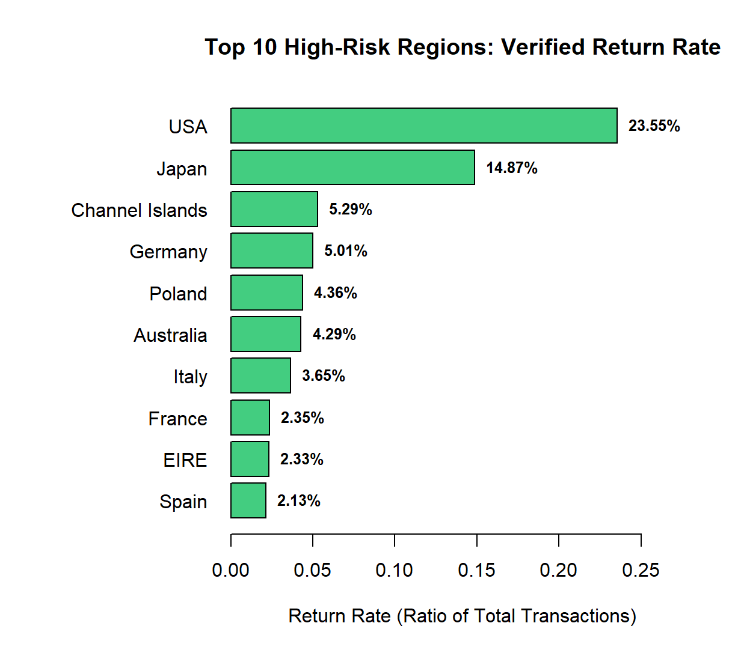
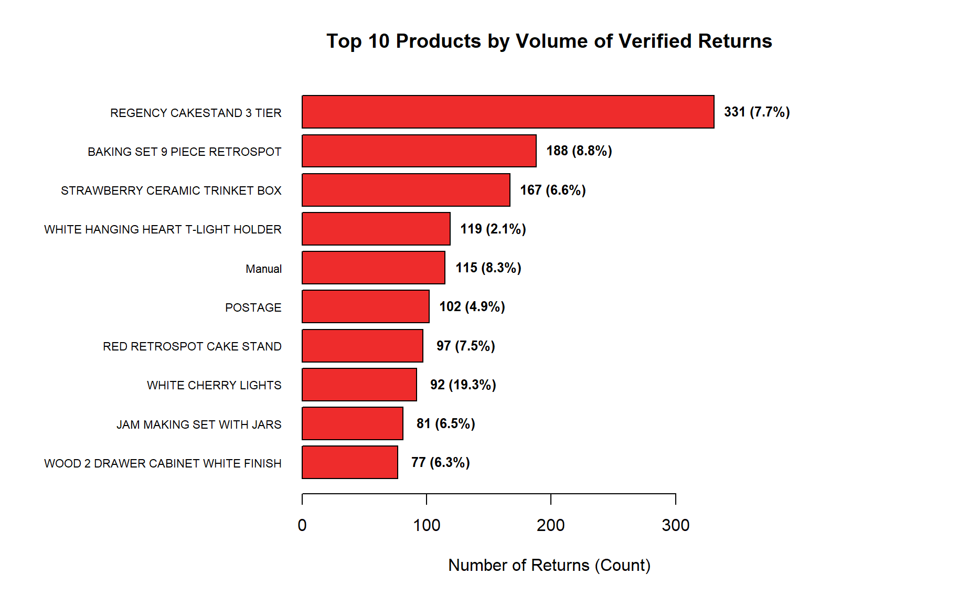

VI. Findings (Results)

To verify that the aggregated total RFM score would be a valuable metric to measure customer value, a table was created to determine if total RFM score had a strong correlation with total revenue generated. As expected, total RFM score was very closely related to average and median revenue (figs. 1 and 2), as well as total revenue generated (fig. 3), making total RFM score a useful metric in determining the value of a customer.
More actionable segmentation conducted by segmenting customers based on their individual RFM components showed that the three segments containing the most customers were Regular Customers, Low Engagement, and Champion, respectively (fig. 6). Revenue contribution per segment was also calculated and visualized (figs. 8-10), which show that the Champion segment, which is composed of customers who have at least a score of 4 in all three RFM components, generates 70.16% of total revenue.
International market revenue analysis showed that customers from the UK dominate total revenue generated (fig. 11), which is unsurprising considering the majority of customers are from the UK. Average monthly revenue growth per country also shows that the UK is growing the most in terms of raw cash flow (fig. 12). Ideally, growth rate would be calculated by month-over-month or quarterly growth in revenue percentage as opposed to raw revenue, however periodic percentage growth in this dataset is unreliable due to the small numbers of customers in many countries. Fluctuations in revenue in countries that contain less than several hundred customers quickly become erratic, causing very large percentage fluctuations, often several hundreds or thousands of percentage points, from period to period. More customers in many countries would be required in order to accurately assess potential market growth outcomes for various international markets.
Customers labeled as probably churned (churn_flag = TRUE) composed about 27.5% of repeat customers, which is a normal churn rate for the retail industry (churn rates in retail fluctuate 20-37% annually; https://customergauge.com/blog/average-churn-rate-by-industry). Using the ‘fromUK’ variable in lieu of country on the unbalanced dataset, the trained logistic regression model scored an accuracy of about 82.1%, with 58% sensitivity and 91.3% specificity. The random forest model scored an accuracy of 80%, with 44.7% sensitivity and 93.4% specificity. Because the goal of the model is to capture churn_flag = TRUE, the model’s overprediction of churn_flag = FALSE, as evidenced by the high specificity and low sensitivity scores, is concerning. After rebalancing the churn dataset to include an equal number of TRUE and FALSE observations, the new and improved scores for the logistic regression model were 79.5% accuracy, 84.6% sensitivity, and 74.5% specificity, while the random forest model scored 78.9% accuracy, 84% sensitivity, and 73.7% specificity. Although overall accuracy of both models decreased slightly when trained on balanced data, the models were much better at correctly predicting when a customer should be flagged for churn, as evidenced by the substantial improvement in sensitivity for both models.
The predictor importance ranking table (fig. 16) shows that the variable tenure_days, the time difference in days between a customer’s first order and last order, is the single most important predictor of churn_flag for both the logistic regression and random forest models. After this, the following top 4 variables are all preferred months (September, October, November) in slightly varying order between the models. After the top 4, the models disagreed on the influence of predictors, with the logistic regressions top ten consisting mostly of more preferred months, while the random forest’s top ten included variables outside months, including total_revenue, interpurchase_days_median, and f_score (frequency score).
The promotion model performs exceptionally well across all three tiers, with F1 scores above 0.94 and AUC scores above 0.999, indicating near-perfect class separation. The only notable soft spot is Medium tier recall at 0.89, meaning roughly one in ten Medium customers is misclassified, though this is a relatively low-stakes error in practice. Variable importance results show that recency_days, n_orders, and total_revenue are the dominant predictors, which is expected and consistent given that the tier labels were deliberately designed around those behavioural concepts — the model has effectively learned to replicate the segmentation logic from raw inputs alone, making it well suited to scoring new customers who do not yet have a full RFM history. The model's three predicted tiers translate directly into distinct promotional strategies.

Class (Propensity Level) | Precision | Recall | F1-Score | AUC
High | 0.9848 | 0.9811 | 0.9829 | 0.9997
Medium | 1.0000 | 0.8919 | 0.9429 | 0.9995
Low | 0.9770 | 0.9928 | 0.9849 | 0.9991

Product & Sales Analysis:

In order to identify the top selling products, total units sold were aggregated for each product description. By focusing on the total quantity sold, the analysis provided a clear representation of the customers’ demands. The results showed that “WORLD WAR 2 GLIDERS ASSTD DESIGNS” was the most frequently purchased product, with over 110,000 units sold. Other highly popular products included “WHITE HANGING HEART T-LIGHT HOLDER”, “ASSORTED COLOUR BIRD ORNAMENT”, and “PAPER CRAFT, LITTLE BIRDIE” (Fig 13). These products consistently appeared among the most purchased items across transactions, indicating that there is a strong and sustained demand for them. Understanding which products are purchased most frequently allows the retailer to prioritize inventory management and ensure that high demand items remain in stock consistently.

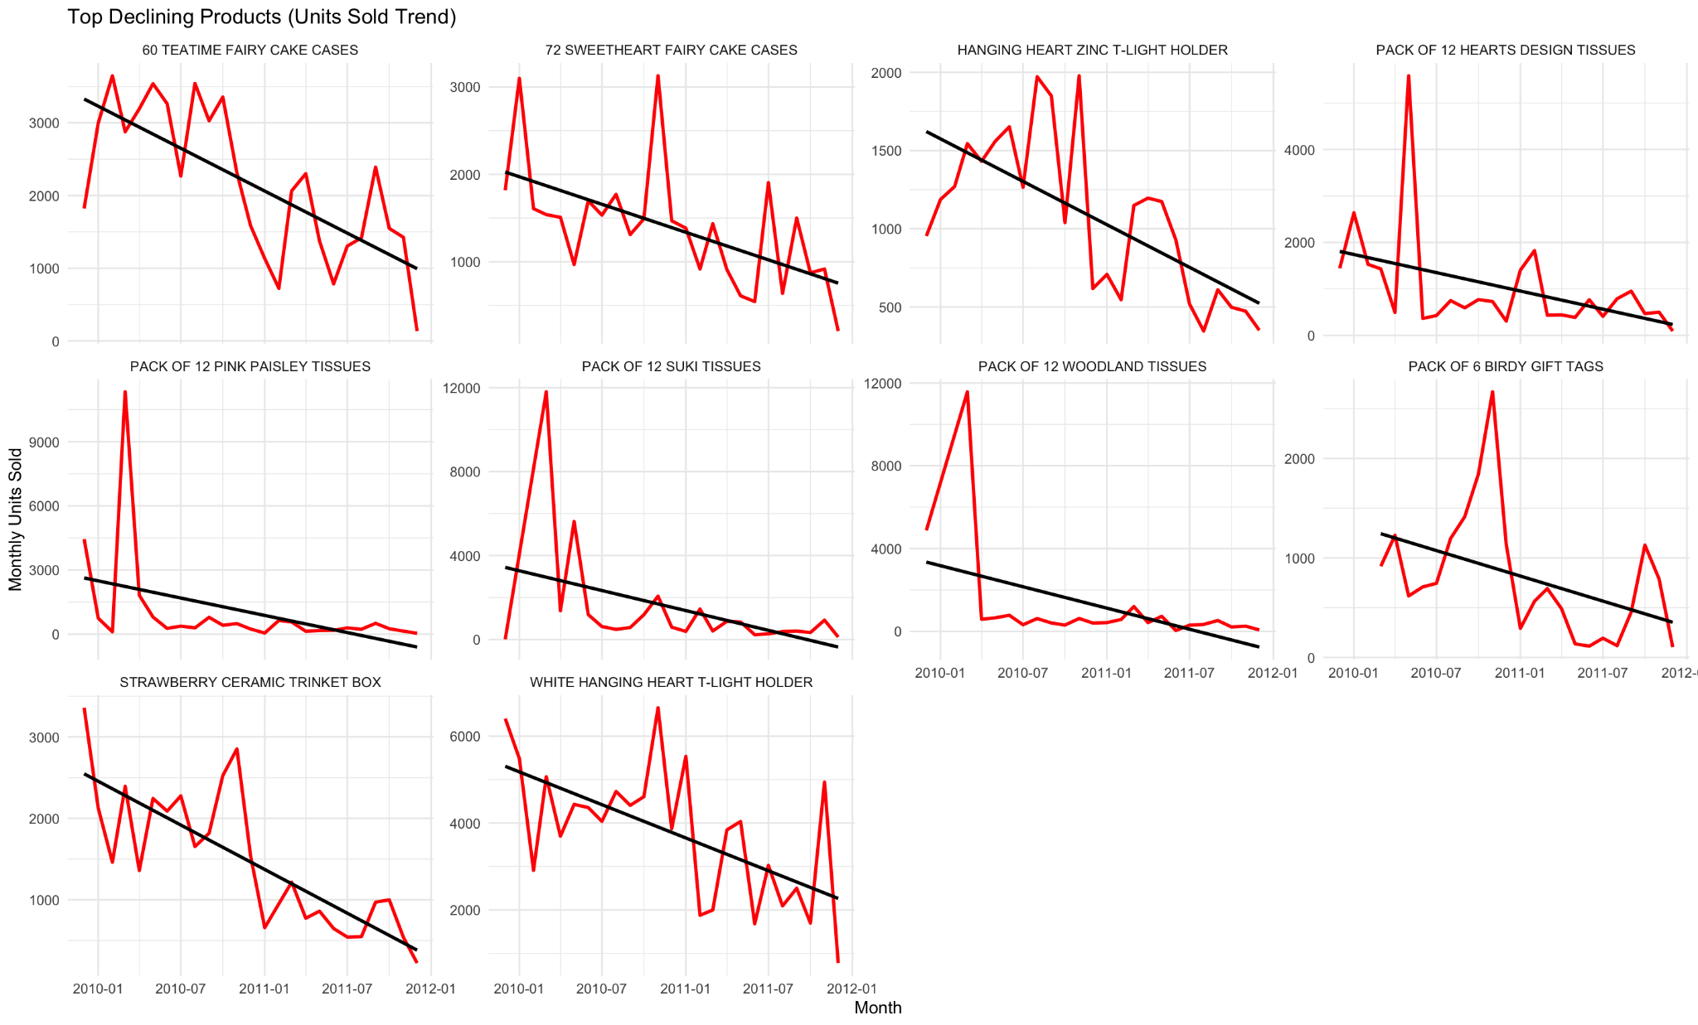
In addition to identifying the top selling products, the analysis also examined whether certain products were experiencing a decline in demand over time. Monthly units sold were calculated for each product and evaluated using linear regression models to determine whether there were statistically significant downwards trends. At first some of the products would appear as a decline but they seemed to be limited time products since the number of units sold would just go straight to zero. To fix this the products were required to have at least 18 months of sales history and recent activity in order to ensure that the trends reflected meaningful patterns rather than the short term or discontinued items. The results showed that several products with a significant negative sales trend. Some of these included “60 TEATIME FAIRY CAKE CASES”, “72 SWEETHEART FAIRY CAKE CASES”, and “PACK OF 12 SUKI TISSUES” (Fig 14). These products show a consistent decrease in units sold over time which therefore indicates a decline in popularity. Declining trends may occur for several reasons, some could be shifts in consumer preferences, product saturation, or a competing product.
Seasonal purchasing patterns were evaluated by aggregating total revenue by month. Revenue was used to analyze the purchase pattern because it reflects the overall financial performance of the retailer during each period rather than simply the number of items sold. The results showed a clear seasonal trend, with revenue increasing significantly towards the end of each year. Specifically, there were large spikes in sales during the months of November and December, which corresponds to the holiday shopping season. Revenue peaked at approximately 1.47 million in later 2010 and 1.51 million in late 2011 (Fig 15). Following the spikes, revenue declines sharply in the early months of the following year. This suggests that a large number of annual sales occurs during the holiday period.
To explore whether future demand could be predicted to improve stock management, a time series forecasting model was applied to one of the top selling products “ASSORTED COLOUR BIRD ORNAMENT.” Monthly units sold were aggregated and modeled using an automated AIRMA time series forecasting approach. The model was used to generate a six-month forecast of expected demand. The forecast suggested that future demand for this product will remain stable with monthly sales ranging between 2,000 and 3,000 units. Although, the prediction intervals are relatively wide due to variability in the sales and the limited length of the data set (Fig 17). The model still provides a useful insight into expected future demand. This forecast can assist retailers in improving stock management by helping estimate future inventory requirements and reducing the risk of both shortages and excess inventory.

Fraud & Detection Analysis:

The fraud detection model performs strongly across the majority of transaction classes, with Bulk.Inventory.Adjustment, Debt.Financial.Adjustment, and Small.Promo.Gift all achieving perfect or near-perfect F1 and AUC scores, and Verified.Customer.Return close behind at 0.94. These results reflect that the invoice prefix and admin stock code features provided the model with clear and distinctive signals for these classes, allowing it to separate them from standard transactions with high confidence.
Two classes present ongoing challenges. Missing.Customer.ID sits at an F1 of 0.57, which is an expected limitation — transactions with missing customer IDs are anomalous precisely because they lack the identifier that would otherwise distinguish them, and their remaining base features such as quantity, price, and country overlap too closely with standard sales for the model to separate them reliably. Unverified.Negative achieves perfect precision but a recall of only 0.65, meaning roughly one in three genuine unverified negatives goes undetected — a silent miss that carries meaningful risk in a fraud detection context. Admin.Fee.Adjustment also shows lower precision at 0.69, indicating the model is generating some false positives for this class, though its AUC of 0.9998 suggests the underlying separation is strong and could be improved with threshold tuning.

Transaction Category | Precision | Recall | F1-Score | AUC
Bulk Inventory Adjustment | 1.0000 | 1.0000 | 1.0000 | 1.0000
Debt/Financial Adjustment | 1.0000 | 1.0000 | 1.0000 | 1.0000
Small Promo/Gift | 0.9969 | 1.0000 | 0.9985 | 1.0000
Verified Customer Return | 0.8965 | 0.9878 | 0.9400 | 0.9993
Admin/Fee Adjustment | 0.6864 | 0.9980 | 0.8133 | 0.9998
Standard Sale | 0.9339 | 0.6745 | 0.7832 | 0.8611
Unverified Negative | 1.0000 | 0.6458 | 0.7848 | 0.9978
Missing Customer ID | 0.4286 | 0.8358 | 0.5666 | 0.8467

VII. Conclusions and Recommendations

In order to properly formulate a promotional campaign to retain and gain new customer engagement, we recommend to use the results from the promotional model to create a tiered - customer system in order to tailor the promotions to each of the three groups. This will ensure maximum yield on expected results. High tier customers — Champions and Loyal Low Spenders — are already engaged and should be rewarded rather than heavily discounted. Loyalty perks, VIP exclusivity, early access offers, and referral incentives are well suited here, with upsell mechanics like minimum spend thresholds being particularly effective for Loyal Low Spenders who purchase frequently but in smaller amounts. Medium tier customers require a split approach: At-risk High Value customers need urgent, time-limited win-back offers with meaningful incentives that reflect their historical spending, while New Customers respond better to first-repeat-purchase discounts and onboarding sequences that build familiarity before harder promotional requests are made. Low tier customers should receive minimal promotional investment — broad low-cost seasonal campaigns at most — with the key actionable insight being to actively suppress this group from expensive personalised campaigns to preserve budget for tiers where return on investment is demonstrably higher. The scored_customers output from the model provides a per-customer probability score for each tier, allowing the marketing team to pull prioritised campaign lists directly without any additional manual segmentation.
Overall, the fraud and detection model is well-suited to assist fraud analysts but should not act autonomously across all classes. The recommended deployment approach is to use high-confidence predictions to auto-resolve the well-performing classes while routing Admin.Fee.Adjustment, Unverified.Negative, and Missing.Customer.ID flags to human reviewers. The most impactful potential improvement would be adding a binary null indicator for the customer ID field, which could substantially strengthen performance on the weakest remaining class.

VIII. Appendix

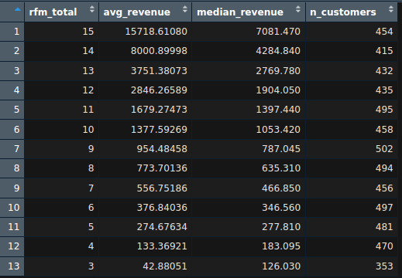
Fig. 1: Table showing relationship between total RFM score and mean/median revenue generated.

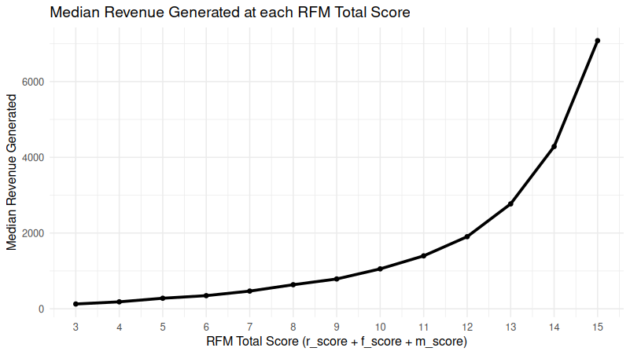
Fig. 2: Plot showing median revenue generated per customer in each total RFM score bin.

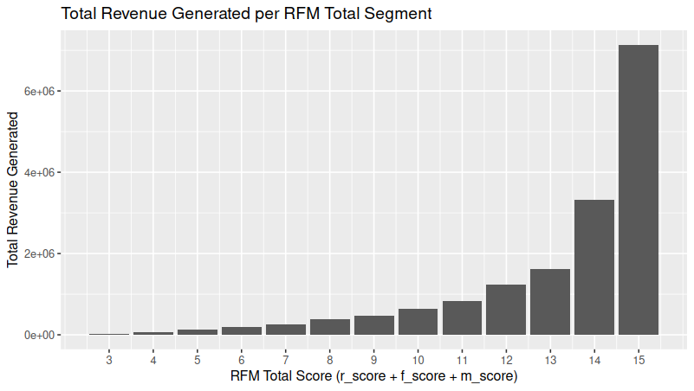
Fig. 3: Total revenue generated by customers in each RFM total score bin.

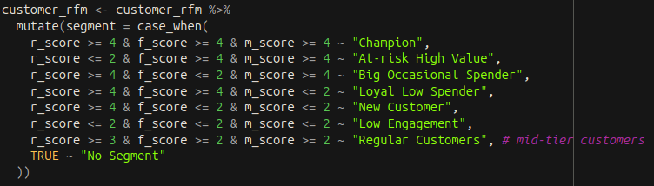
Fig. 4: Customer segmentation based on RFM components.

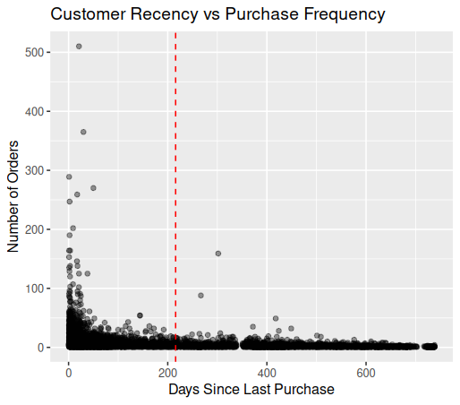
Fig. 5: Concentration of customers with low number of orders increases as recency decreases (days since last purchase increases). Inclusion of one-time buyers (e.g. non repeat-customers) will inflate churn threshold (red line).
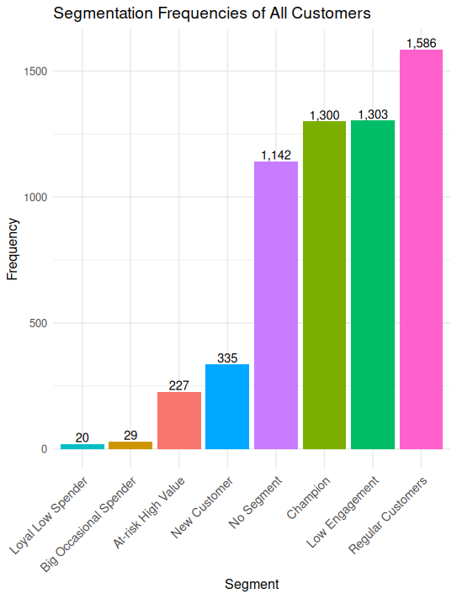
Fig. 6: Number of customers in each segment.

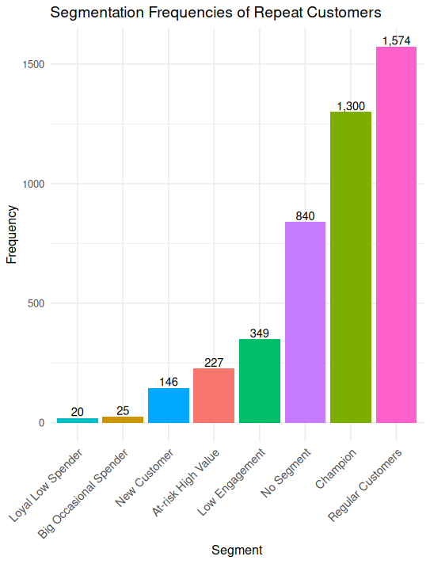
Fig. 7: Number of repeat customers in each segment. Notice that Low Engagement saw a marked decrease from the plot showing all customers.

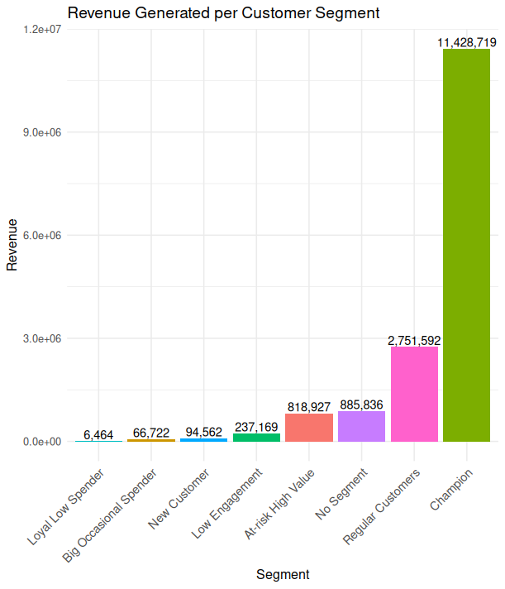
Fig. 8: “Champions” overwhelmingly contribute the most to revenue. In fact, they contribute more than double of the rest of the segments combined.

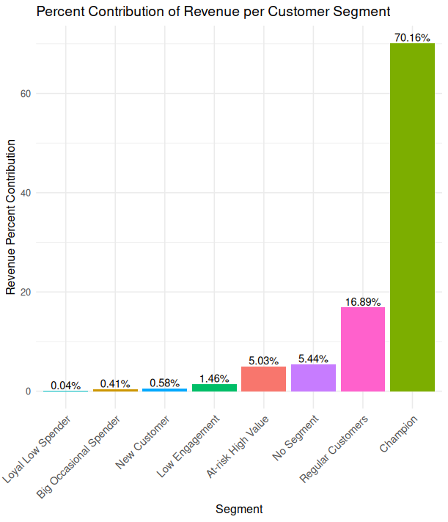
Fig. 9: Percentage revenue contribution by segment.

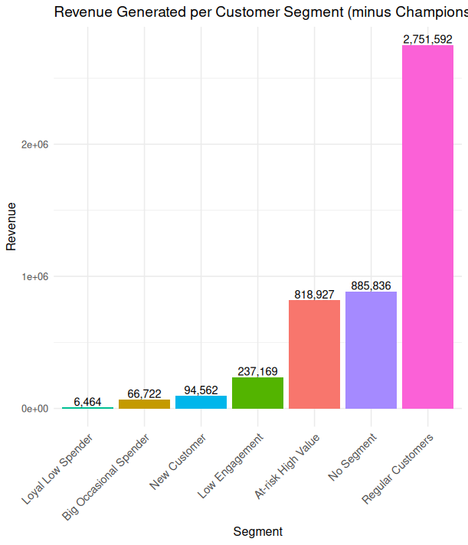
Fig. 10: Revenue generated per segment, without champions segment.

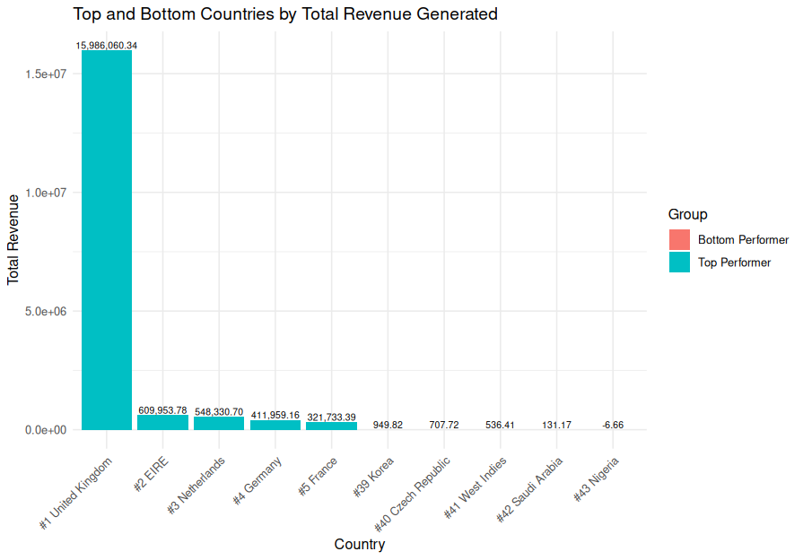
Fig. 11: Revenue generated per country. Only includes top 5 and bottom 5 out of 43 country levels.

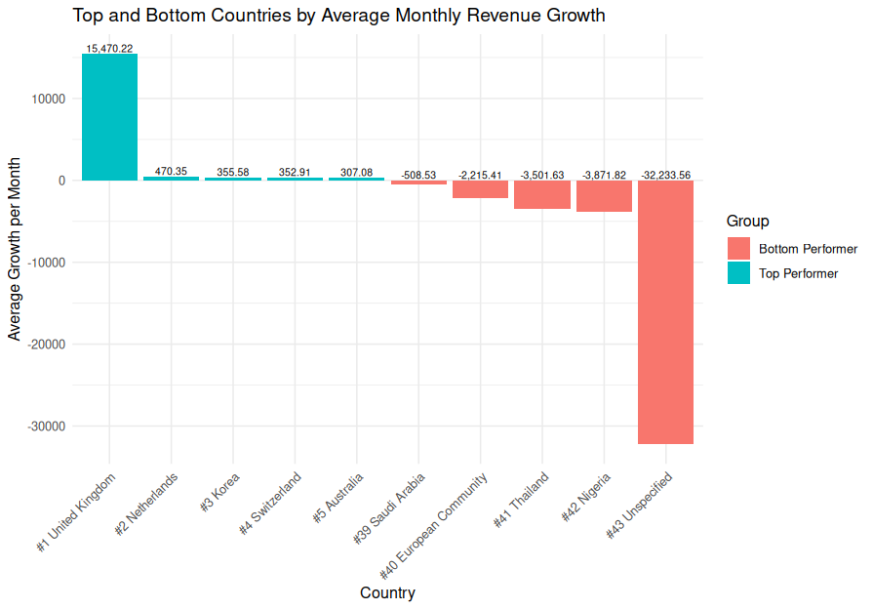
Fig. 12: Average monthly revenue growth per country.

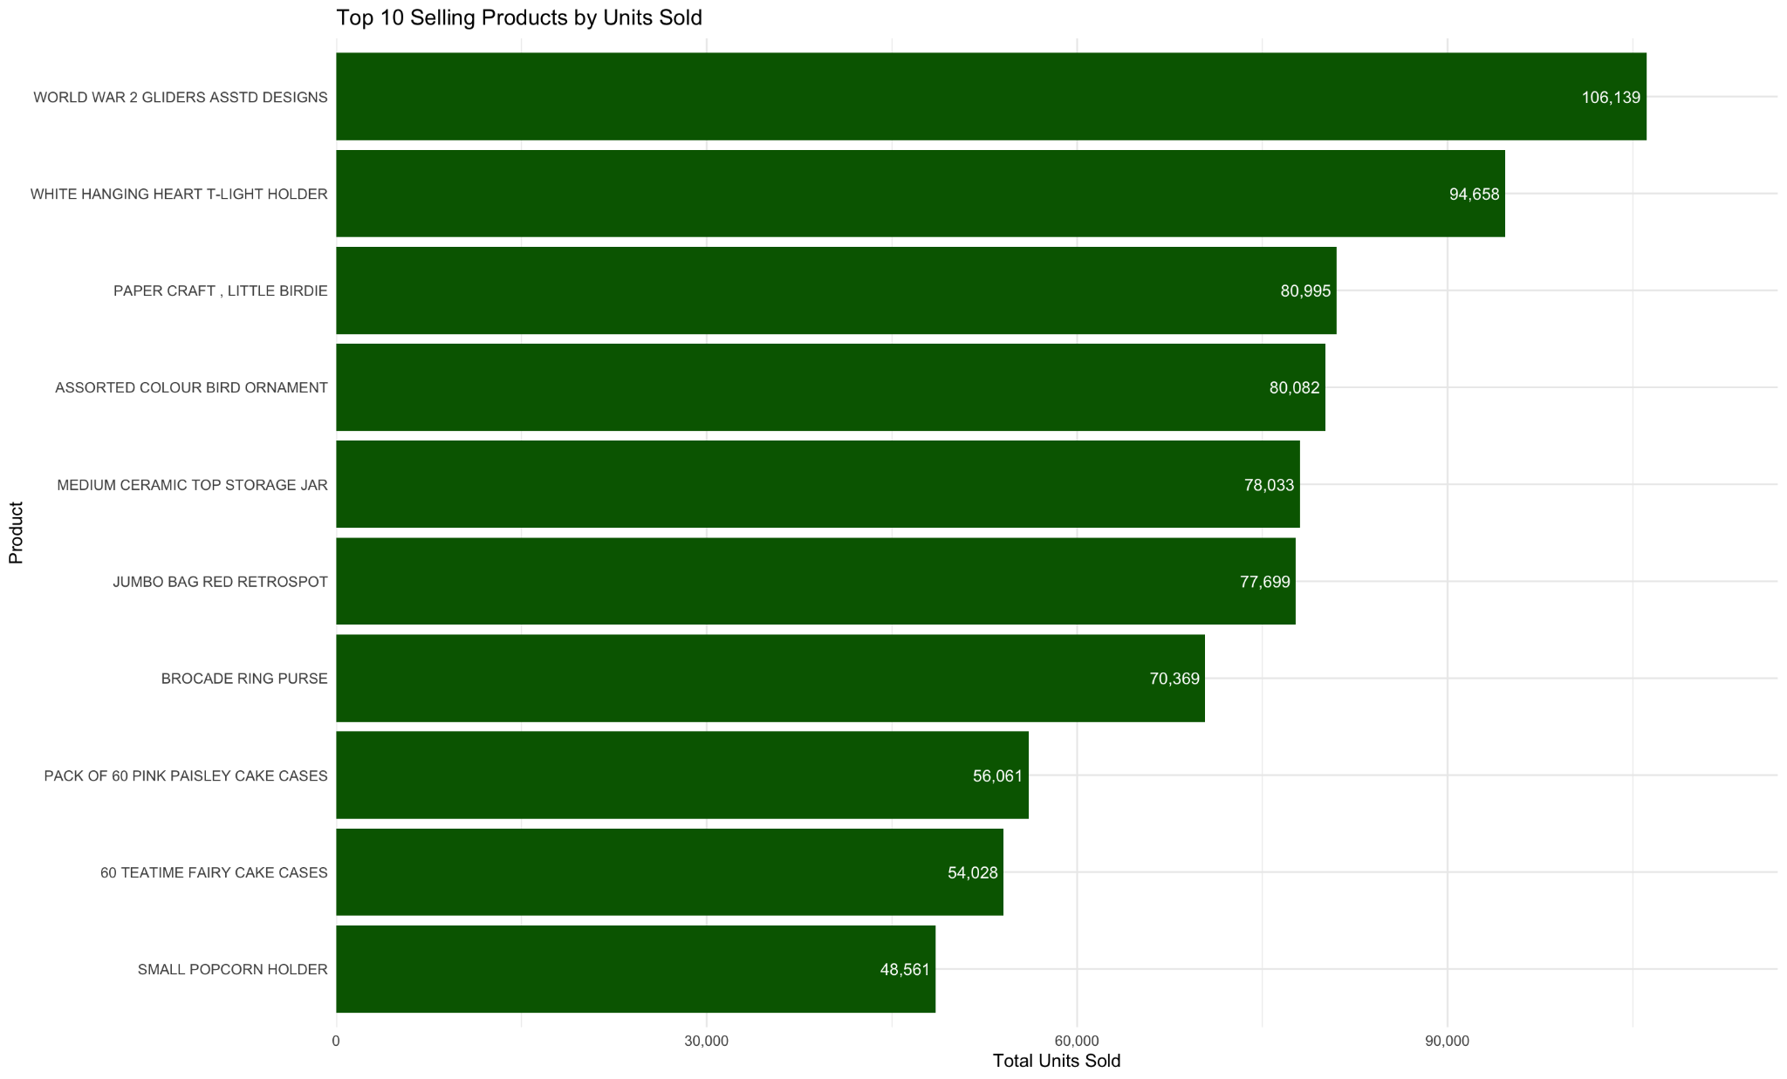
Fig 13: Top 10 Selling Products by Units Sold


Fig 14: Top Declining Products(Units Sold)

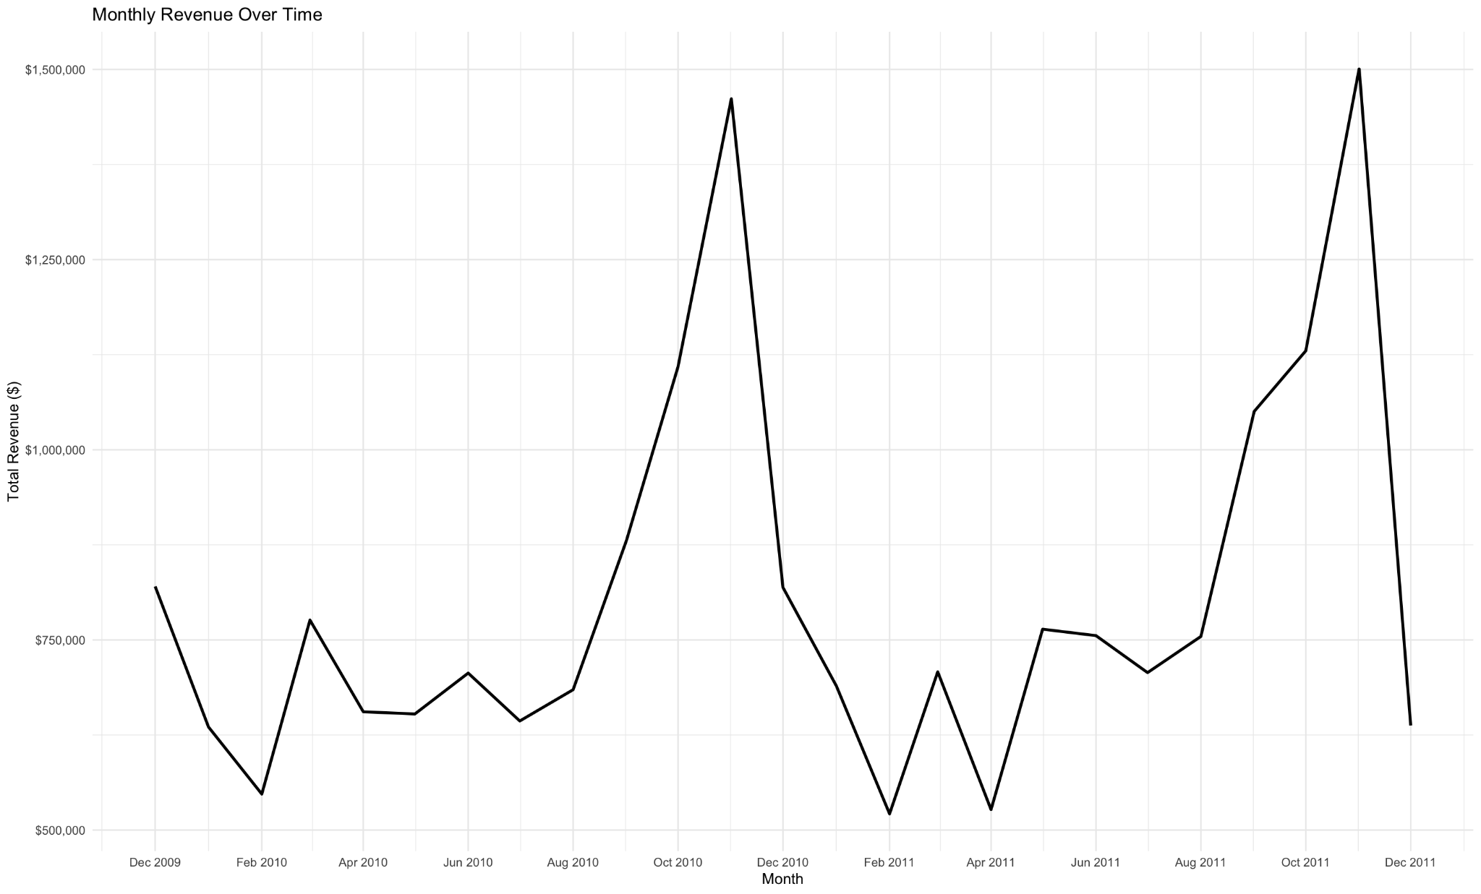
Figure 15: Monthly Revenue Over Time. Jumps in revenue around christmas time, confirming that there are seasonal patterns.

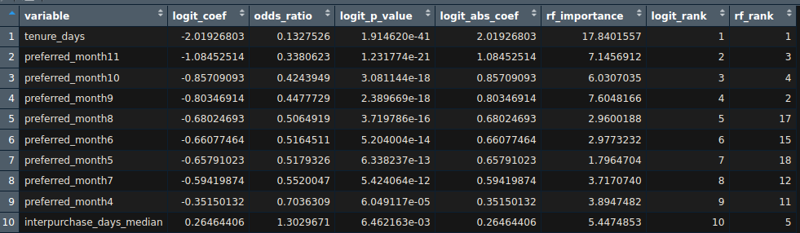
Fig. 16: Top 10 predictors for predicting customer churn, ranked by absolute value of estimated logit coefficient. Tenure_days, the number of days between a customer’s first and last orders, is the single most important predictor variable, followed mostly by preferred months.

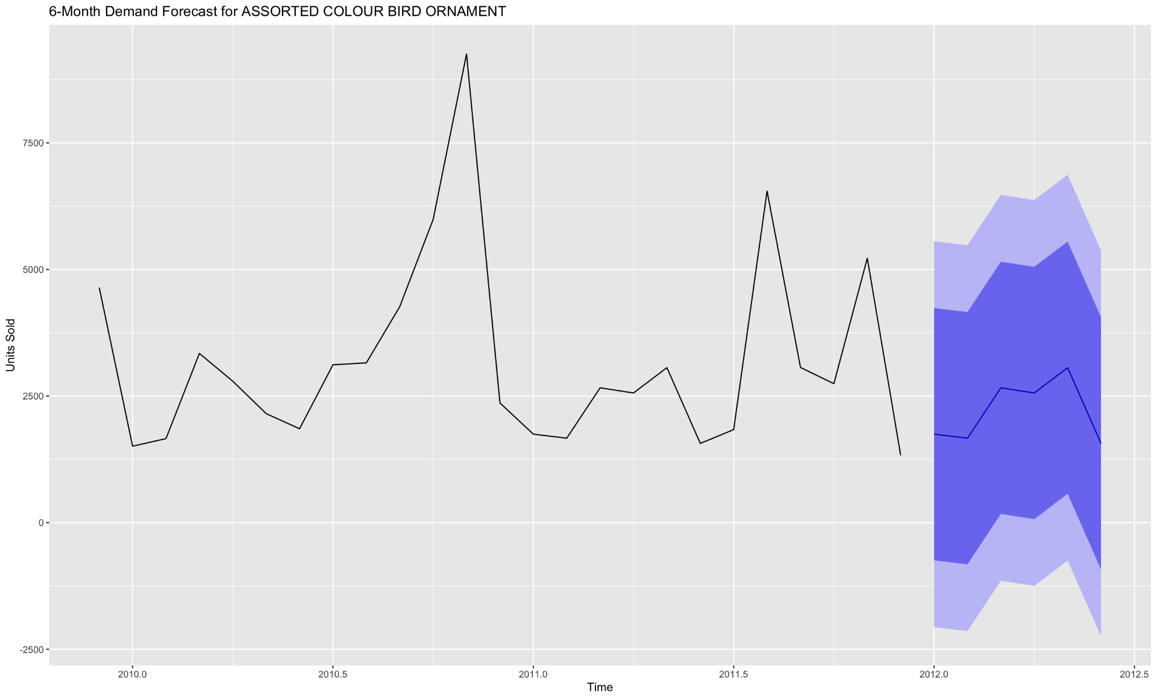
Fig 17: 6 Month Demand Forecaster for ASSORTED COLOUR BIRD ORNAMENT

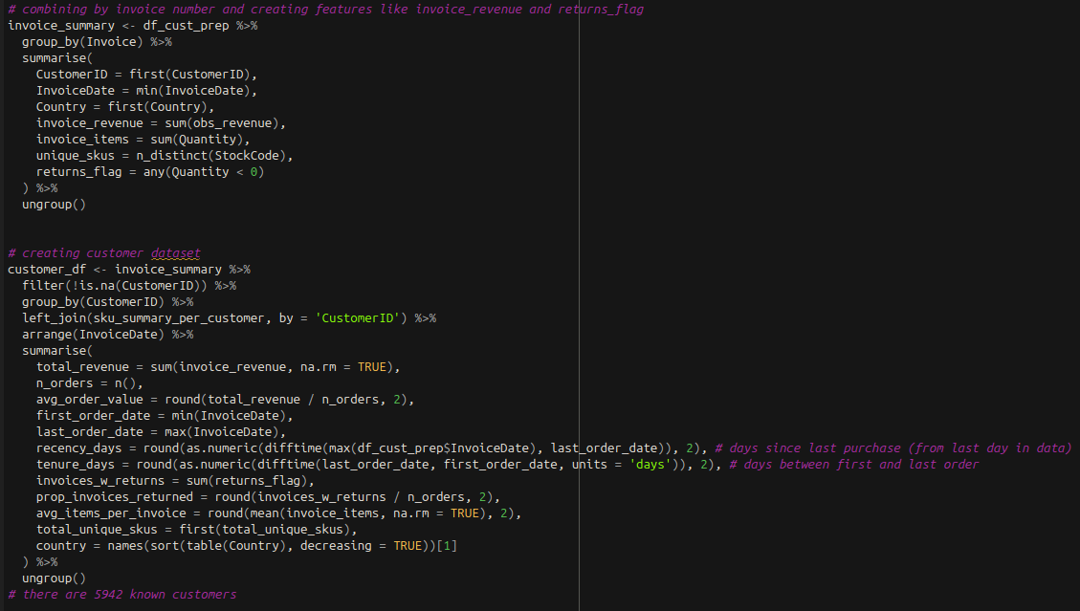
Fig. 18: Feature engineering of customer dataset to create variables eventually used in the creation of RFM variables.
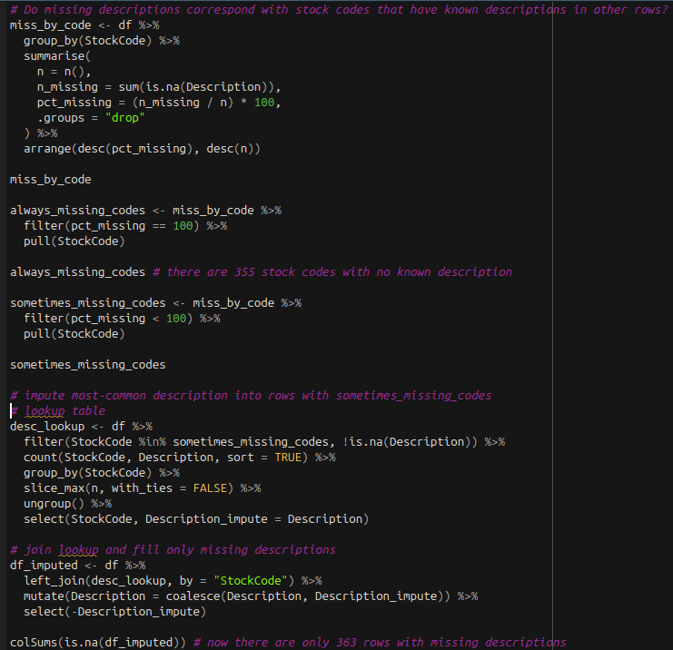
Fig. 19: Imputation of missing descriptions by stock codes where stock codes exist in rows with not null descriptions.

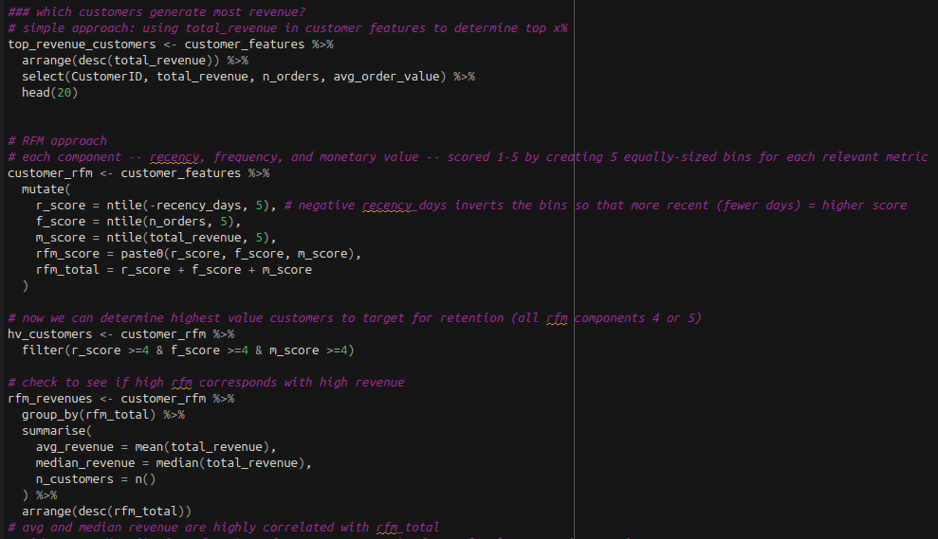
Fig. 20: Creation of RFM variables using previously created customer features recency_days, n_orders, and total_revenue.

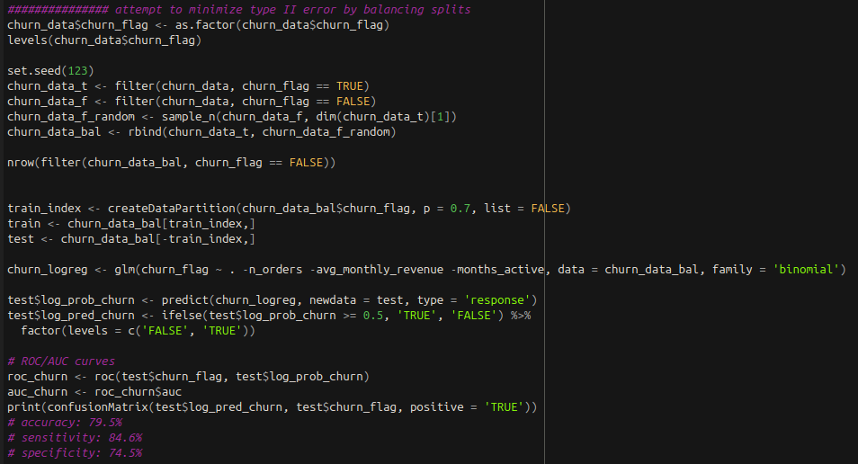
Fig. 21: Creating balanced churn datasets and training of logistic regression model.
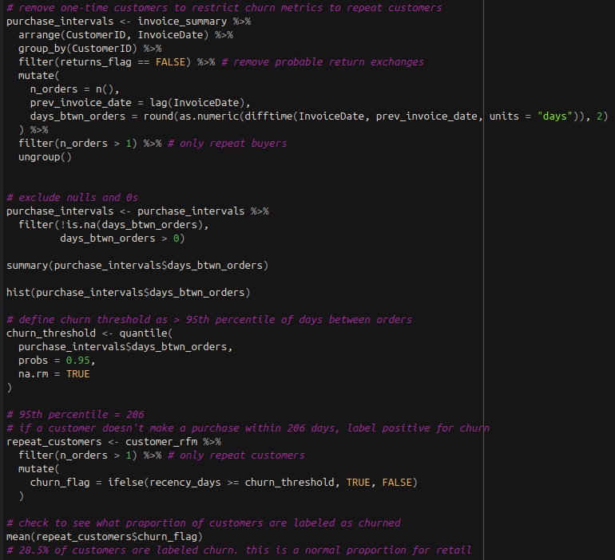
Fig. 22: Creation of churn_flag boolean.

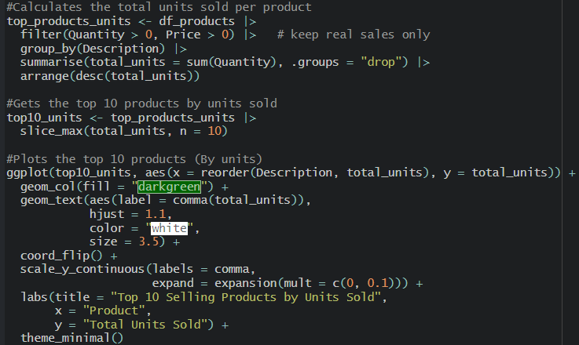

Fig 23: Creation of bar chart identifying the top 10 selling products based on total units sold across all transactions. This visualization highlights the products with the highest customer demand.
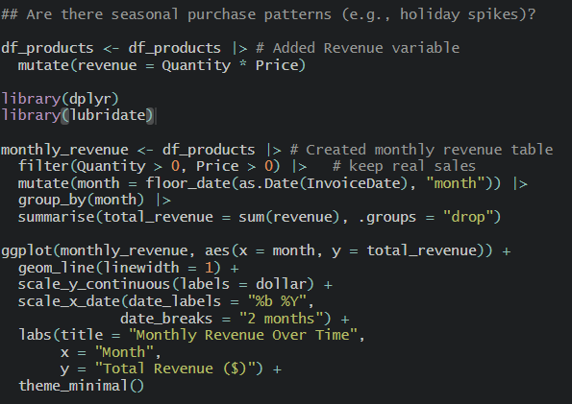
Fig 24: Creation of time series line chart showing the total monthly revenue over time

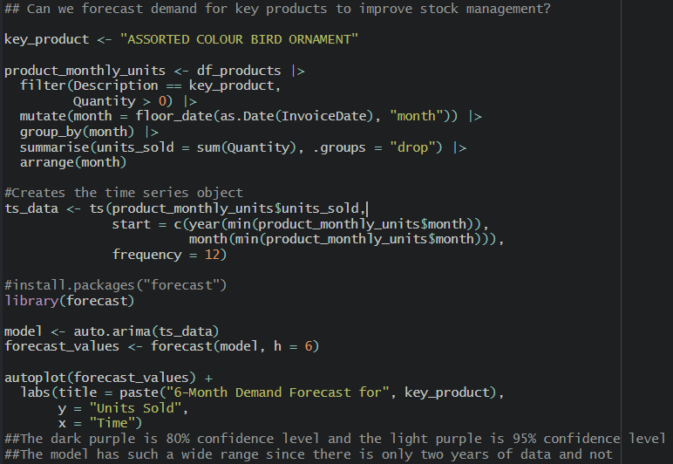
Fig 25: Created a 6 month demand forecast for a select high volume product using an ARIMA time series model.
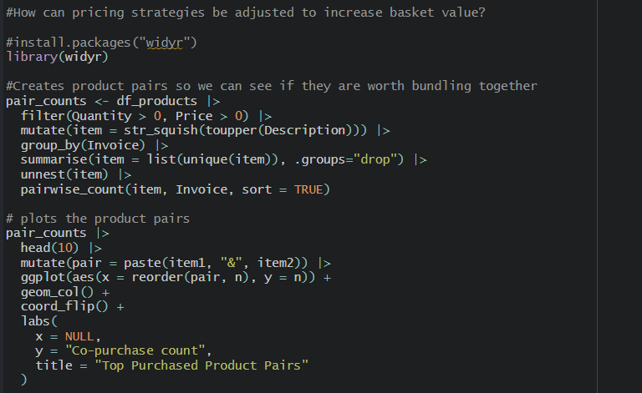
Fig 26: Creation of a products frequently bought together

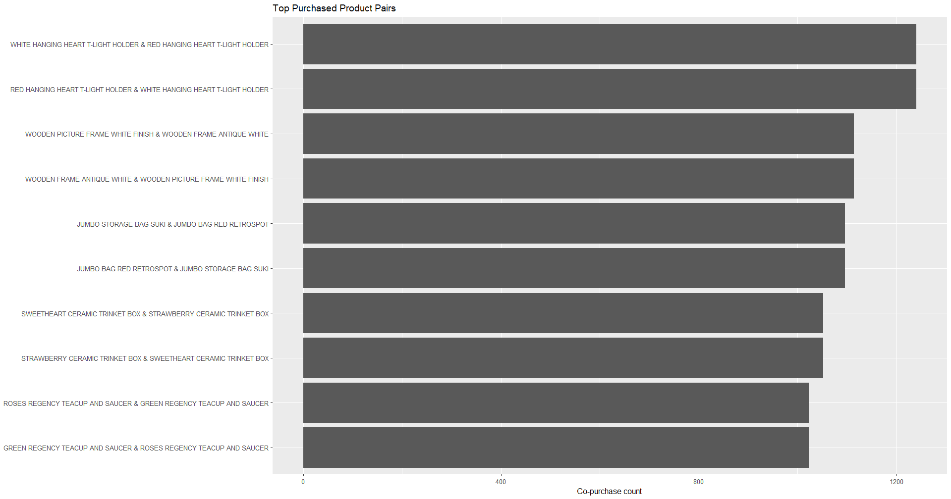
Fig 27: Barplot showing the products frequently bought together

Fraud / Anomaly Logic & Model:

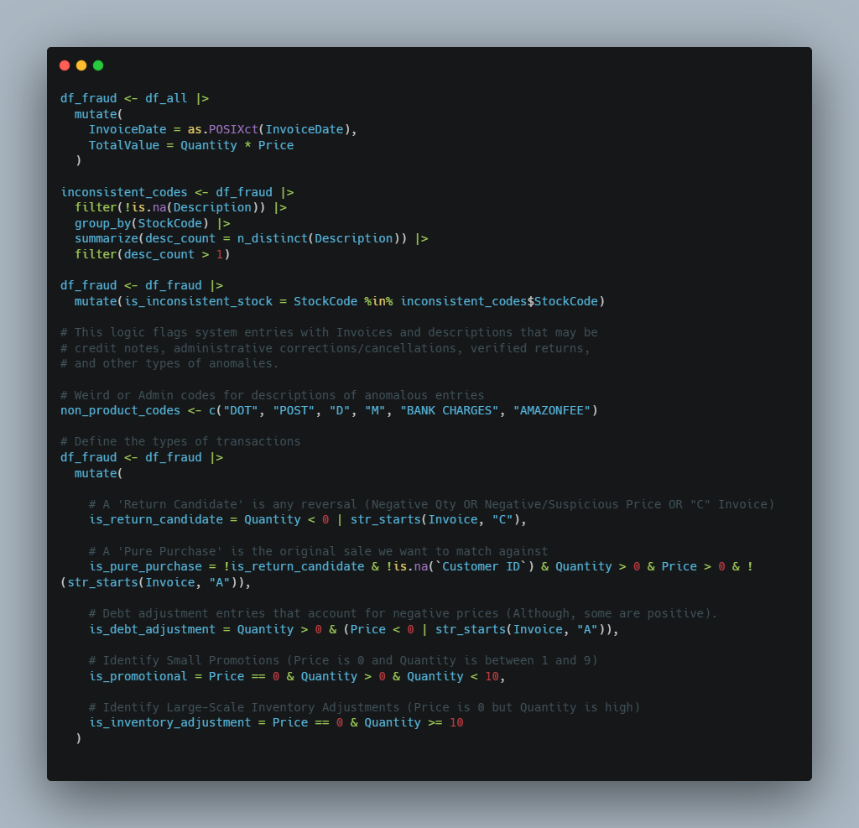
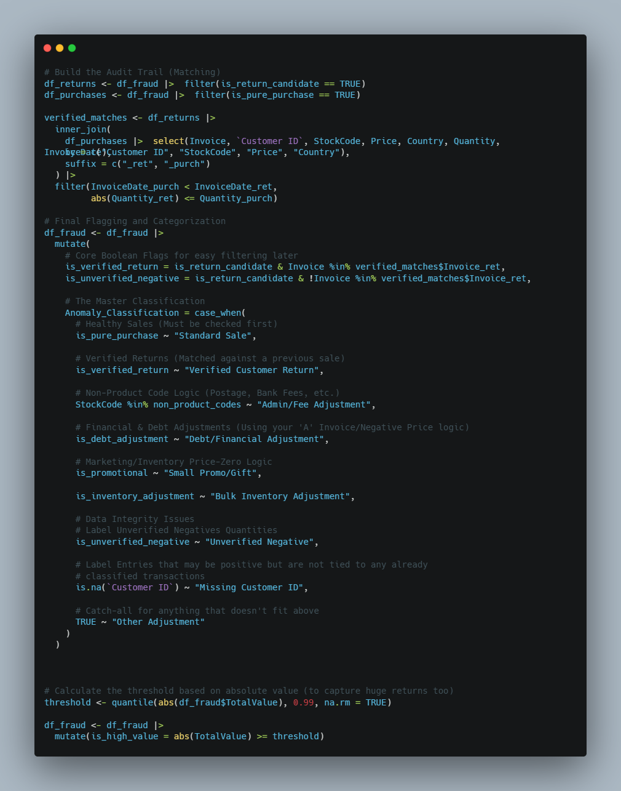
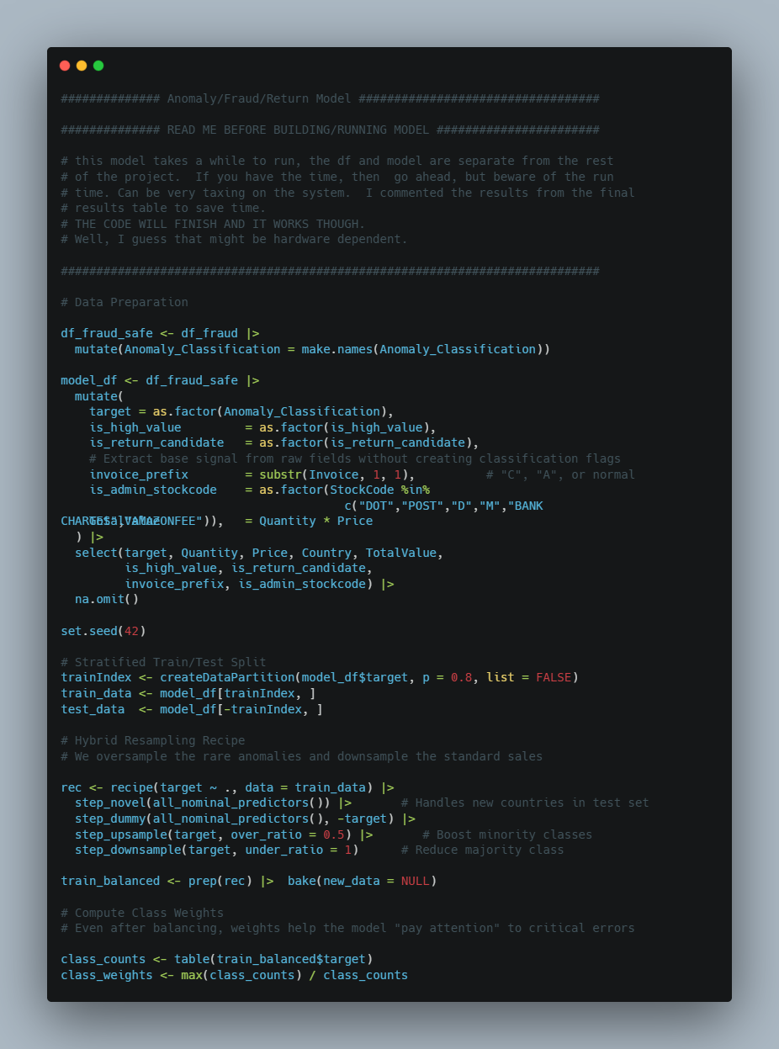
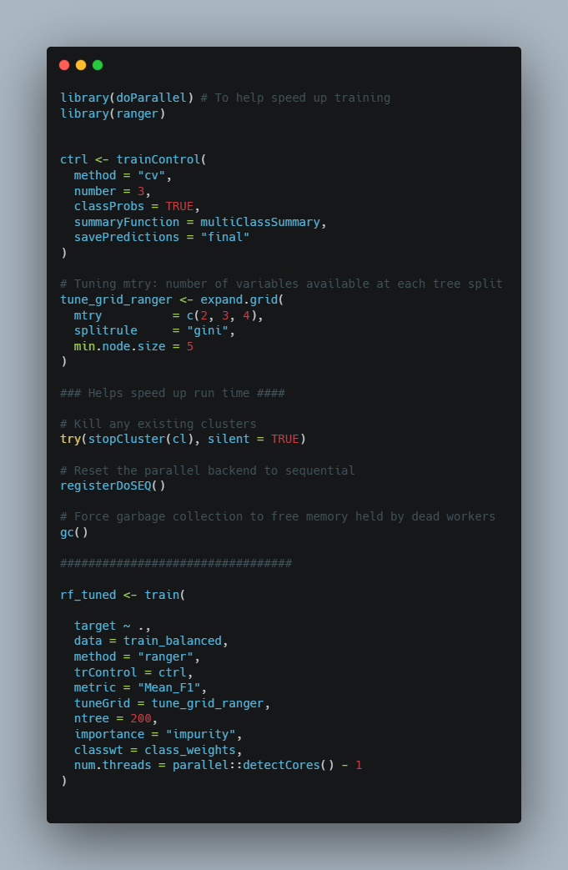
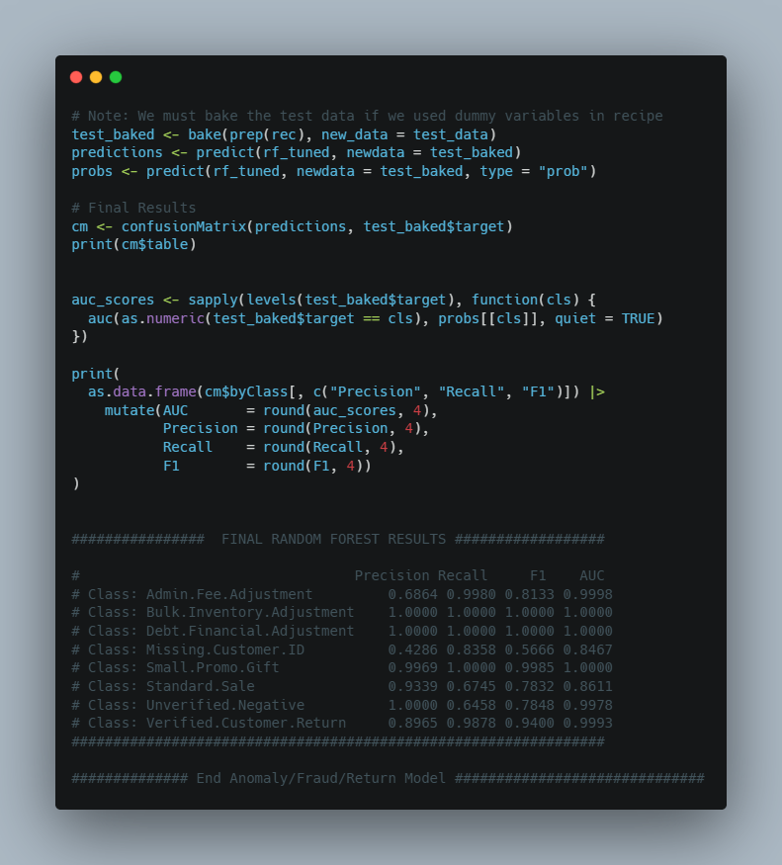

Promotions Model Logic:

